Computer Systems and Internet Technologies - COMP1589

Hypertext Markup Language (HTML)
Lab

SUMMARY
In this lab you will learn how to create a basic webpage using the building blocks of the internet, HTML as well as becoming familiar with Visual Studio Code and browser developer tools.
For all labs I’d recommend you use Visual Studio Code and Google Chrome.

OBJECTIVES
- To become familiar with creating HTML files within Visual Studio Code
- To create a basic “Hello World” HTML webpage
- To become introduced to the developer tools in the browser

TASK
Before starting this task, and to help in future tasks, it’s worth planning your folder organisation. I’d strongly recommend creating a dedicated folder for this module, and within that folder create a new folder per week.
Step 1
Open your code editor of choice, generally I’d suggest a lightweight text based editor but you may prefer a fully fledged IDE. Within the lab and lectures we will be using Visual Studio Code.
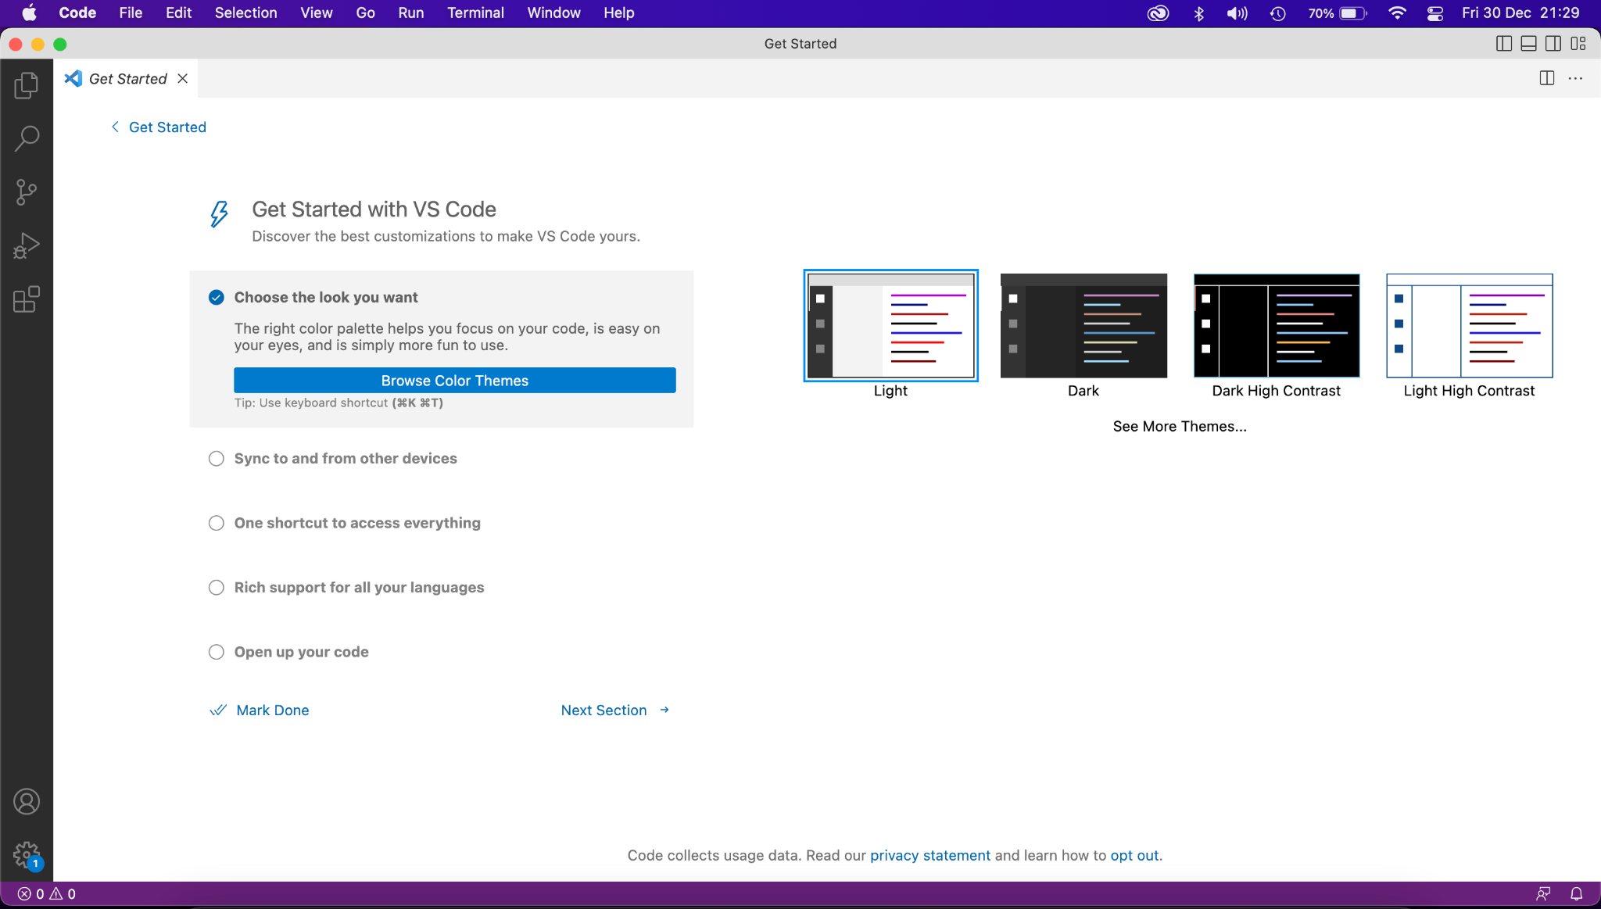
Step 2
Create a new file, you can do this with the keyboard shortcut “ctrl + n” and select the language as HTML - be sure to save it also.
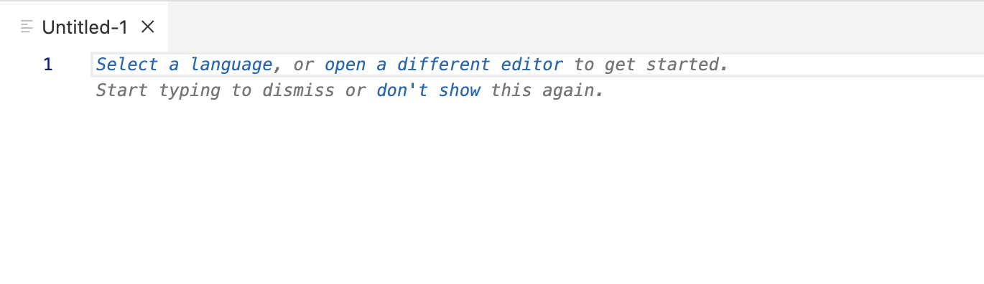
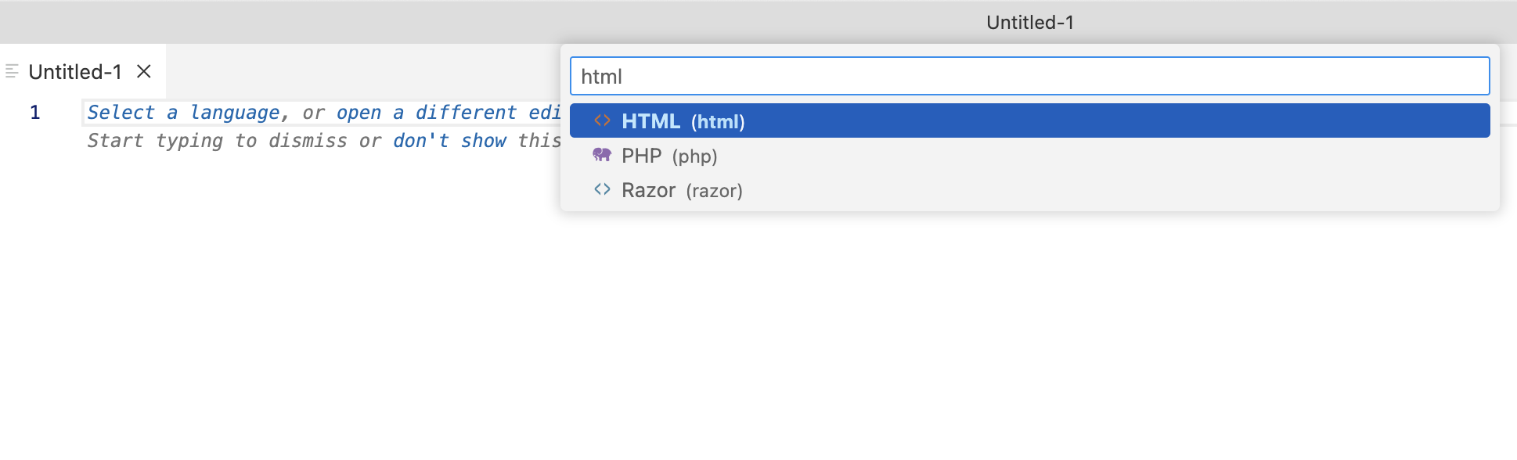
Or by using the “File” menu and clicking “new file”, name the file whatever you want but ensure you have the HTML extension, for example “week1.html”.
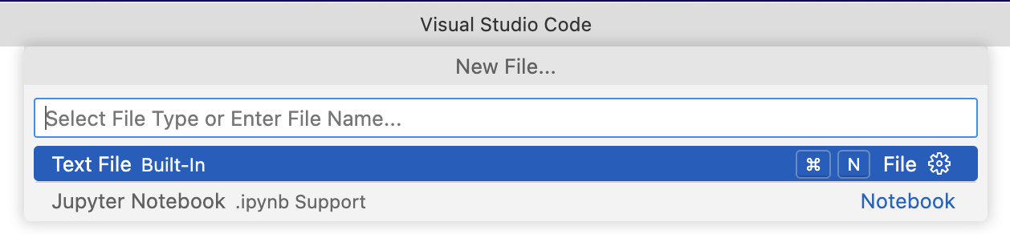
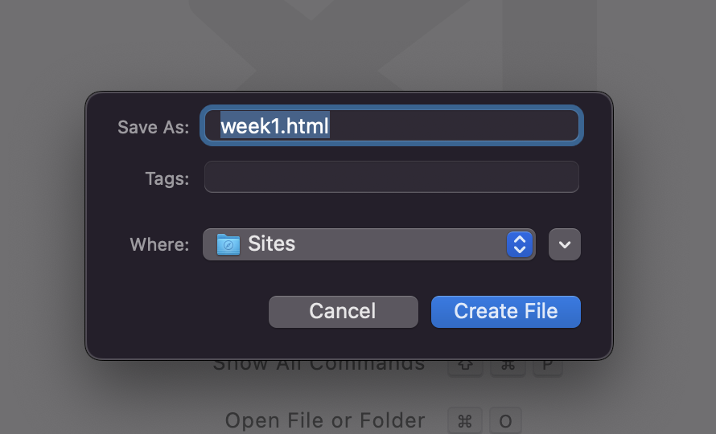
Step 3
Now copy and paste the below boilerplate code to get started:
<!DOCTYPE html>
<html lang="en-GB">
<head>
<!-- This is a comment, it's visible in the source but not on the page -->
<meta charset="utf-8">
<meta name="viewport" content="width=device-width, initial-scale=1">
<title>Hello World</title>
</head>
<body>
<h1>Hello World</h1>
</body>
</html>
Once you’ve saved this code let’s view it, locate the file you created in finder/explorer and double click to open it in your browser.
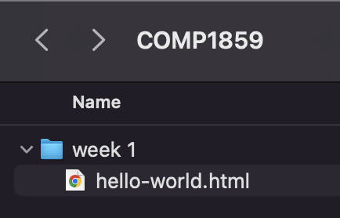
It should look something like this:
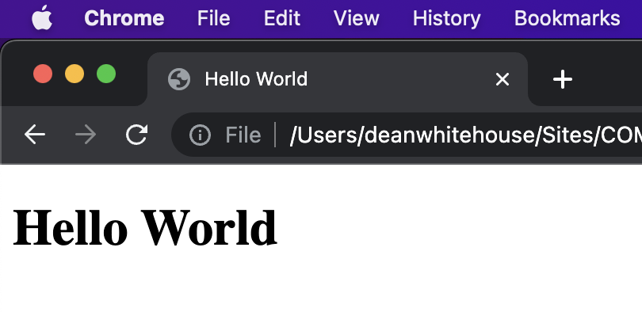
Step 4
Let’s check out our source to understand the code a bit better, right click on the page and select “View Page Source”. It should look something like the below:
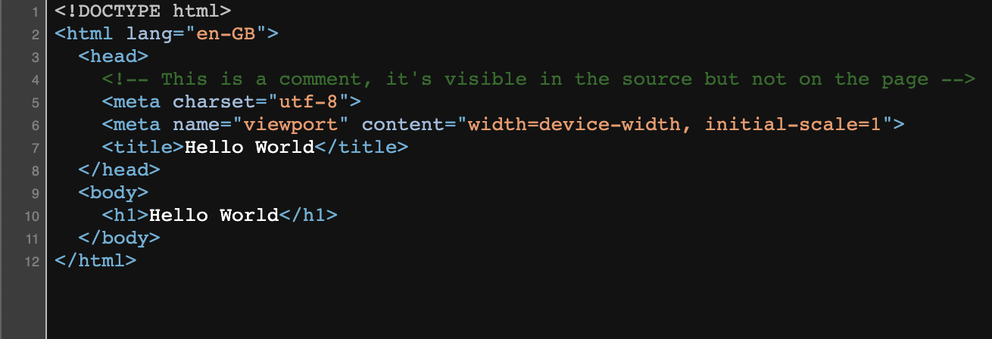
Let’s break this down line by line…
Doctype
<!DOCTYPE html>
This is not actually a HTML tag, but rather information for the browser to understand what version of HTML to treat this file as.
The above is for HTML5, generally this will be all you need for modern web development however if you have to support very old browsers you may wish to declare HTML 4.01 or XHTML 1.1.
HTML
<html lang="en-GB">
The HTML tag is the top level element of your HTML file. Within this we nest the <head> and <body> tags, which then hold most other tags. The lang attribute inside the opening tag sets the language for the page - this is beneficial for search engines and accessibility reasons, helping screen readers know how to properly pronounce the text.
Head
<head>
<!-- This is a comment, it's visible in the source but not on the page -->
<meta charset="utf-8">
<meta name="viewport" content="width=device-width, initial-scale=1">
<title>Hello World</title>
</head>
This tag contains information that is processed by machines. Inside the <head> tags we nest our metadata which is data that describes the document to the machine.
Our first line is our comment tag, this allows us to leave comments within our code to help us better understand it when we come back to it. However be wary, even though this code doesn’t show to the user in the browser, it does show in the source (as you can see when using “view page source”) so do not put anything confidential in these.
<!-- This is a comment, it's visible in the source but not on the page -->
Next we have one of our meta tags, we will look at these a little more over the coming weeks but these are special tags that allow us to describe how our page should be processed, displayed and interpreted by search engines (or similar tools).
Our first meta tag sets our page encoding, this determines what characters we can use. UTF-8 is the standard character encoding you should use in your web pages, this is a unicode standard that allows many languages and symbols. This will usually be the first <meta> tag shown in the <head> element.
<meta charset="utf-8">
We then have our viewport meta tag, this determines how our webpage should respond across different screen sizes - this is known as responsive. The values used in this tag ensure our website width matches the viewport width on the device and our initial scale is 1 (100%).
<meta name="viewport" content="width=device-width, initial-scale=1">
Finally we have our <title> tag, this is the title for the web page and it is shown in the browser's title bar and sometimes used elsewhere such as in search engine results.
<title>Hello World</title>

Body
The <body> element defines the document's body, and is a container for all the visible contents, such as headings, paragraphs, images, hyperlinks, tables, lists, etc.
<body>
<h1>Hello World</h1>
</body>
You can see within our body tag we have a H1 tag, this is a heading tag - by default browsers will render tags like this in a standard way, next week we will look at how we can impact the look of these tags.
Step 5
Now that you’ve got a very basic webpage up and running in the browser, let’s have a look at adding in some more complexity.
Hyperlinks
These allow us to connect web pages together and the user to navigate between them.
<a href="https://www.gre.ac.uk/" target="_blank">Visit the University of Greenwich website!</a>
The “href” attribute determines where the user should be taken when they click the link, this can be relative (i.e. “/webpage2.html”) or absolute such as what we have in currently.
The second attribute, “target”, determines where we should open the new web page. If you omit this attribute then it’ll simply navigate to the link within the current tab, however as we are using “_blank” it does this in a blank tab.
Images
No modern website is complete without some form of graphic, this is most commonly via the “img” tag. The below tag lets us simply include an image, from a relative or absolute location, within our page.
<img src="https://www.gre.ac.uk/__data/assets/image/0035/265688/logo_final_on_white.png" alt="University of Greenwich Logo" />
The “alt” attribute provides accessibility support for those with screen readers primarily, ensuring that they can understand what the image is trying to portray.
Step 6
When you’re done having a play with those additional tags then we can finish up by exploring the browsers developer tools, these are a critical part of web development and for this part of the task I’d strongly recommend using Google Chrome.
Within your browser, open your web page (using “File”, Open; or simply drag and drop your HTML file into the browser). Now right click on the text and click “Inspect”.
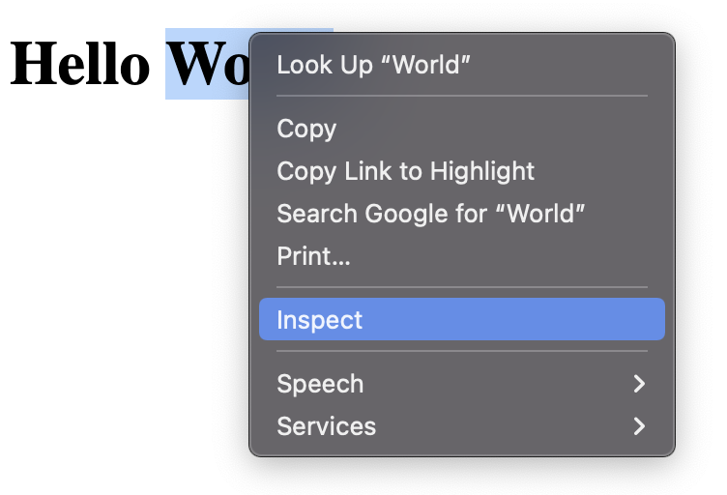
This will open up our developer tools, which should look something like:
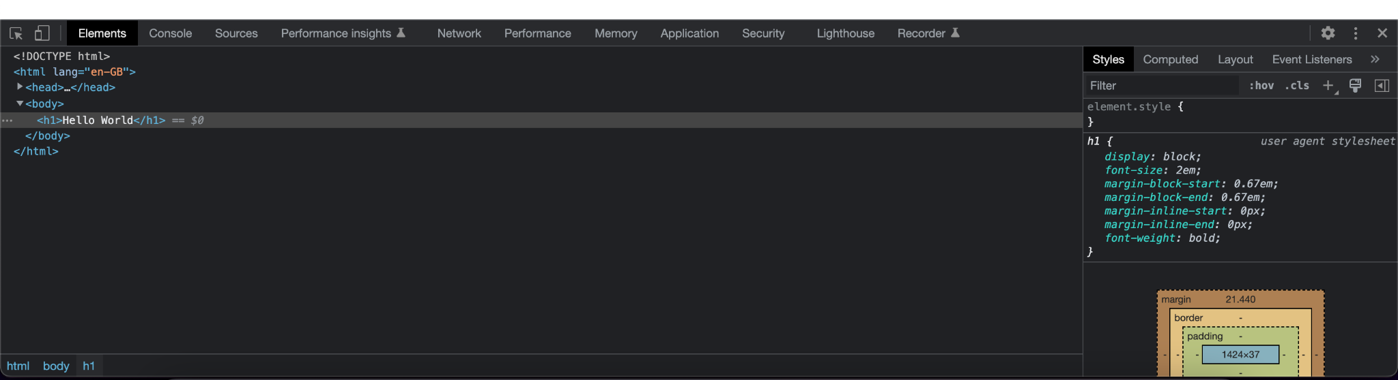
We won’t go into detail on these right now but please do have a play around in your own time to get a good understanding.
The main concepts to understand at this moment are the “elements” tab and the “styles” sidebar, these help you understand how your HTML code is viewed by the browser (this is not the same as “View Page Source” even though it looks it, this is what our code looks like after the browser has processed it).
Using the “elements” tab we can identify elements within the page and even change these to test out what things may look like, give it a try changing “Hello World” to “Hello Earth” in your H1 tag. Once you’ve done this, refresh the page and you’ll notice your change is simply forgotten.
Within the “style” sidebar you can see the default styling the browser is applying, try clicking on the “body” element and you should see some default margin (space) and if you hover over that element it should highlight this in the browser and show that margin. We can also add our own custom styles in this sidebar, we will look at that more next week.

EXTRA
If you’ve completed all the steps above then spend some time experimenting with HTML further or getting to know the developer tools in your preferred browser.
HTML Elements
HTML elements reference
HTML Cheatsheet | CodeWithHarry
Dev Tools
Chrome DevTools
Firefox DevTools
Develop menu in Safari
Microsoft Edge DevTools

